Question 01
i)
SQL> CREATE TABLE TEACHER(T_ID CHAR(06) PRIMARY KEY, T_NAME VARCHAR(10),T_STATUS CHAR(03),T_DEPT CHAR(04));
SQL> CREATE TABLE COURSE (C_ID CHAR(06) PRIMARY KEY, C_NAME VARCHAR(30), C_LEVEL CHAR(03));
SQL> CREATE TABLE STUDENT(S_ID CHAR(05) PRIMARY KEY, S_NAME VARCHAR(20), S_STATUS CHAR(03));
SQL> CREATE TABLE ENROLMENT(C_ID CHAR(06),S_ID CHAR(05), FOREIGN KEY(C_ID) REFERENCES COURSE(C_ID), FOREIGN KEY(S_ID) REFERENCES STUDENT(S_ID));
SQL> CREATE TABLE COURSE_SCHEDULE(C_ID CHAR(06), T_ID CHAR(06), FOREIGN KEY(C_ID) REFERENCES COURSE(C_ID), FOREIGN KEY(T_ID) REFERENCES TEACHER(T_ID));

II)
INSERT ALL
INTO TEACHER VALUES('01121','Mark','P','IT')
INTO TEACHER VALUES('01122','Silvester','P','ITE')
INTO TEACHER VALUES('01123','Henyang','AP','ITE')
INTO TEACHER VALUES('01124','Garcia','L','IT')
INTO TEACHER VALUES('01125','Leon','P','MA')
INTO TEACHER VALUES('01126','Susan','AP','ITE')
INTO TEACHER VALUES('01127','Swan','P','IT')
INTO TEACHER VALUES('01128','Rolinta','P','IT')
INTO TEACHER VALUES('01129','Borva','AP','IT')
SELECT * FROM DUAL;

INSERT ALL
INTO COURSE VALUES('IT110','Introduction to Computers','F')
INTO COURSE VALUES('IT348','Information Systems','S')
INTO COURSE VALUES('IT250','Web Programming','SP')
INTO COURSE VALUES('IT448','Introduction to DB','S')
INTO COURSE VALUES('MA511','Vector Analysis','GR')
INTO COURSE VALUES('IT503','Artificial Intelligence','GR' )
INTO COURSE VALUES('MA513','Graph Theory','GR')
INTO COURSE VALUES('ITE264','Object Oriented Programming','S' )
INTO COURSE VALUES('ITE255','Computer Architecture','S')
SELECT * FROM DUAL;

INSERT ALL
INTO STUDENT VALUES('124','Georgia','F')
INTO STUDENT VALUES('125','Kim','S')
INTO STUDENT VALUES('126','Walls','SP')
INTO STUDENT VALUES('127','Hannah','GR')
INTO STUDENT VALUES('128','Dundi','GR')
INTO STUDENT VALUES('129','Eloniwa','S')
INTO STUDENT VALUES('240','Sanyen','SP')
INTO STUDENT VALUES('241','Bintar','F')
SELECT * FROM DUAL;

INSERT ALL
INTO ENROLMENT VALUES('IT110','240')
INTO ENROLMENT VALUES('IT110','241')
INTO ENROLMENT VALUES('IT348','125')
INTO ENROLMENT VALUES('IT348','129')
INTO ENROLMENT VALUES('IT348','127')
INTO ENROLMENT VALUES('IT250','126')
INTO ENROLMENT VALUES('IT250','241')
INTO ENROLMENT VALUES('ITE264','126')
INTO ENROLMENT VALUES('ITE264','127')
INTO ENROLMENT VALUES('ITE264','128')
INTO ENROLMENT VALUES('MA513','126')
INTO ENROLMENT VALUES('IT503','128')
INTO ENROLMENT VALUES('IT503','129')
INTO ENROLMENT VALUES('IT448','240')
INTO ENROLMENT VALUES('IT250','240')
INTO ENROLMENT VALUES('MA511','240')
SELECT * FROM DUAL;

INSERT ALL
INTO COURSE_SCHEDULE VALUES('IT110','01124')
INTO COURSE_SCHEDULE VALUES('IT348','01127')
INTO COURSE_SCHEDULE VALUES('IT250','01128')
INTO COURSE_SCHEDULE VALUES('IT448','01124')
INTO COURSE_SCHEDULE VALUES('MA511','01125')
INTO COURSE_SCHEDULE VALUES('IT503','01129')
INTO COURSE_SCHEDULE VALUES('MA513','01125')
INTO COURSE_SCHEDULE VALUES('ITE264','01123')
INTO COURSE_SCHEDULE VALUES('ITE255','01126')
SELECT * FROM DUAL;

QUESTION 02
1)
SELECT T_NAME FROM TEACHER WHERE T_DEPT ='ITE';
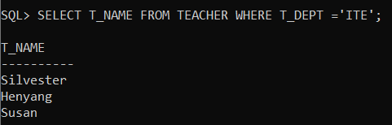
2)
SELECT S_NAME FROM STUDENT WHERE S_ID IN (SELECT S_ID FROM ENROLMENT WHERE C_ID = 'IT250');
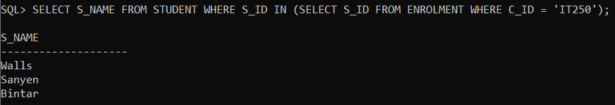
03)
SELECT T.T_NAME FROM TEACHER T, COURSE_SCHEDULE CS WHERE T.T_ID = CS.T_ID AND CS.C_ID = 'MA513';
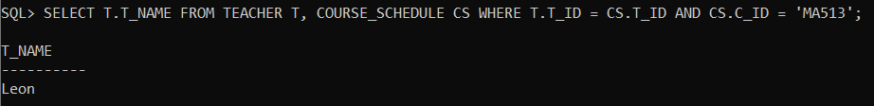
04)
SELECT S_ID,S_NAME FROM STUDENT WHERE S_ID IN ( SELECT S_ID FROM ENROLMENT WHERE C_ID = 'IT348' AND C_ID ='ITE264' OR C_ID = 'IT503');
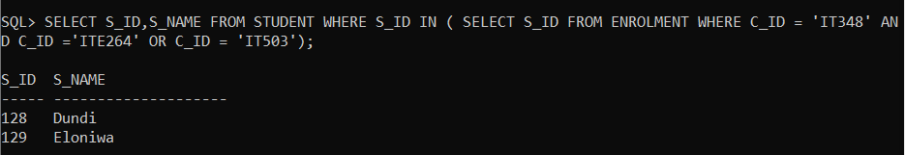

05)
SELECT C.C_ID, C.C_NAME, A.STUDENT_COUNT FROM COURSE C , (SELECT C_ID,COUNT(S_ID) AS STUDENT_COUNT FROM ENROLMENT GROUP BY C_ID) A WHERE C.C_ID = A.C_ID;
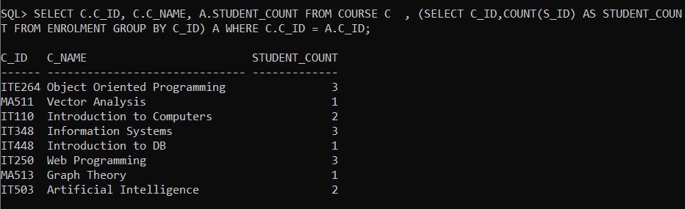
06)
SELECT S.S_NAME,D. COURSE_COUNT FROM STUDENT S, (SELECT S_ID,COUNT(C_ID) AS COURSE_COUNT FROM ENROLMENT GROUP BY S_ID) D WHERE S.S_ID = D.S_ID AND (D.COURSE_COUNT = 1 OR D.COURSE_COUNT = 3);
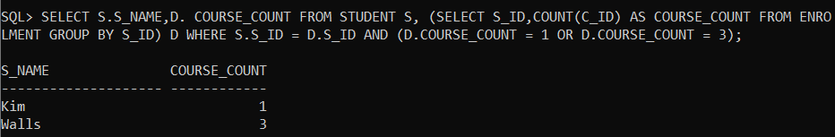
07)
SELECT S_NAME FROM STUDENT WHERE S_ID IN (SELECT S_ID FROM ENROLMENT WHERE C_ID IN (SELECT C_ID FROM COURSE_SCHEDULE WHERE T_ID IN (SELECT T_ID FROM TEACHER WHERE T_NAME = 'Swan')));
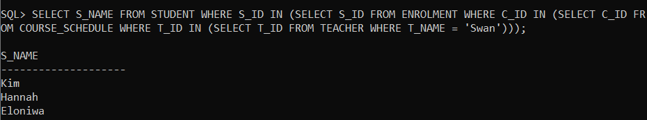

08)
SELECT C_ID, C_NAME FROM COURSE WHERE C_ID IN (SELECT C_ID FROM ENROLMENT WHERE S_ID IN (SELECT S_ID FROM STUDENT WHERE S_STATUS ='GR')) AND C_LEVEL IN ('F','S',’SP’);
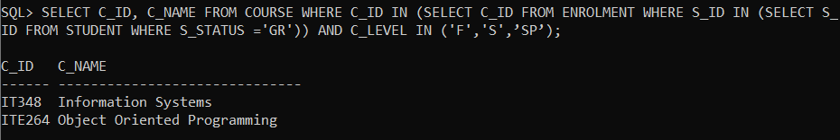
09)
SELECT S_NAME FROM STUDENT WHERE S_ID IN (SELECT S_ID FROM ENROLMENT WHERE C_ID IN (SELECT C_ID FROM COURSE_SCHEDULE WHERE T_ID IN (SELECT T_ID FROM TEACHER WHERE T_NAME = 'Leon'))) AND S_STATUS IN ('F','S',’SP’);
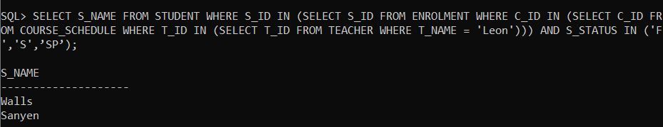
10)
SELECT S_ID FROM STUDENT WHERE S_ID IN (SELECT S_ID FROM ENROLMENT WHERE C_ID IN (SELECT C_ID FROM COURSE_SCHEDULE WHERE T_ID IN (SELECT T_ID FROM TEACHER WHERE T_NAME = 'Garcia')));